Ideation Phase

Define the Problem Statements

Date | 01 February 2026
Team ID | LTVIP2026TMIDS24078
Project Name | DocSpot: Seamless Appointment Booking for Health
Maximum Marks | 2 Marks

Customer Problem Statement
- Who is experiencing the problem? Freelancers—both newcomers and experienced professionals—across various domains such as design, writing, tech, and marketing.
- What are they trying to accomplish? They aim to find legitimate, relevant, and well-paying freelance jobs quickly and efficiently, without spending excessive time sorting through spam or low-quality listings.

What is standing in their way?
  - Overcrowded platforms with inconsistent filtering and irrelevant job results
  - Scam listings or jobs with unclear expectations and poor compensation
  - Delayed response times and lack of client transparency
  - Difficulties in establishing trust and showcasing portfolios effectively
  - Competitive saturation leading to underbidding wars

How are they currently addressing this issue?
  - Subscribing to multiple freelance platforms and manually sifting through listings
  - Using job aggregators, which often lead to outdated or duplicate listings
  - Joining social media or niche communities that may lack structure or security

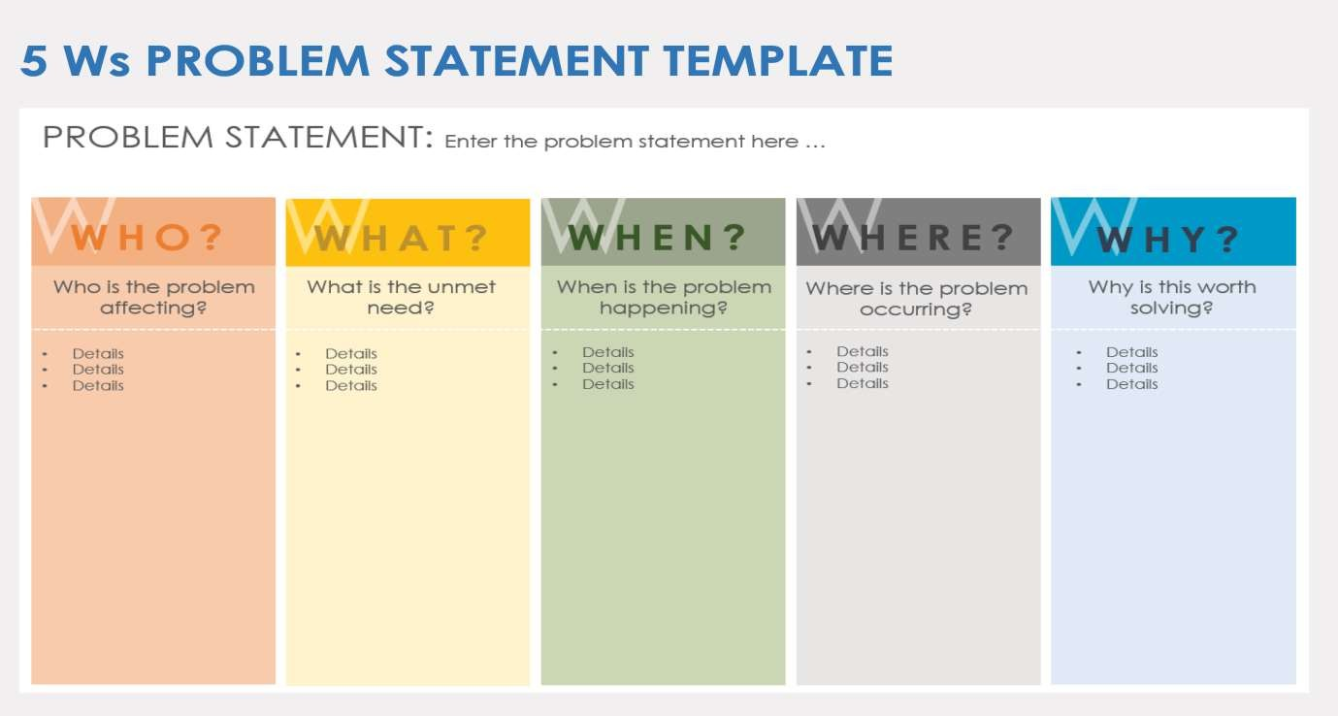

Problem  Statement (PS) | I am  (Customer) | I’m trying to | But | Because | Which makes me feel
PS-1 | a working professional with a tight schedule | book a doctor’s appointment quickly without phone calls or long wait  times. | most clinics don’t have real-time booking systems or clear availability  info | their systems are outdated or fragmented | frustrated and anxious about my health getting worse while waiting.
PS-2 | a general physician running a small clinic. | manage patient bookings efficiently and reduce no-shows. | my current tools are manual or not tailored to healthcare  workflows. | I cannot afford or understand complex clinic manageme-  nt systems. | stressed and underpaid despite my busy schedule.

